Leadership development and succession planning within a board of trustees are often conducted in a just-in-time manner. Yet these processes work best if given advance thought and planning. The tools that follow lay out a framework to assist you in that thinking and planning process with a focus on the competencies of individual trustees.
Competency-Based Leadership Development
and Succession Planning Tools

The sections below are offered to support your thinking about the kinds of competencies your board will need in various leadership positions and how to assemble or build them so you have more than one viable candidate for each position when it comes open.

1. How the Competencies of Effective Board Leaders “Look”
Every board has a variety of leadership positions to be filled. As a result, it’s important for the Chair, Nominating Committee, or others who are engaged in filling those positions to understand what it “looks like” when a board leader is demonstrating the target leadership competencies. Recognition of the presence or absence of those behaviors and why those behaviors are so important to board and committee effectiveness helps ensure that the most appropriate and capable trustees are nominated to committee chair and board chair positions.

Exhibit 1, on the following page, lists the 15 core Personal Capability competencies that were identified by the Center for Health Care Governance’s Blue Ribbon Panel on Trustee Core Competencies and Work Group. For each, in alphabetical order, the exhibit offers an explanation of how each contributes to a board leader’s effectiveness. The nominating body for each board will find that the particular competencies that matter most in a given leadership role will vary, depending on the issues facing the board at any given point in time and looking into the future. As a result, it will be important to review these competencies carefully with an eye to each individual leadership role to be filled before embarking on the nomination process.

2. This Board’s Leadership Opportunities
This section outlines a series of discussion topics and related questions that will lead the board’s officers or Governance Committee to identify how the strategic challenges facing the board and the way the board has operated in the past can help define which of these competencies is most important at a given time for a given leadership role.

This board’s strategic situation
• How would we characterize this institution’s competitive situation?
• Does that situation require that the institution make any major changes in order to sustain or improve its market and financial condition?
Exhibit 1: How Trustee Competencies Are Applied By Effective Board Leaders
Individual Competency | Important for Leaders Because:
Accountability | The leader of a board, a committee, or a working group is responsible to ensure that required work products are created. Leaders must set clear expectations about the nature of the output required, formulate a defined agenda for pursuing that work, and ensure that each member of the group (whether a trustee, staff member, or other volunteer) provides the needed participation, contribution, and reliability to ensure that deliverables are generated on schedule and at needed levels of quality.
Achievement Orientation | The standards that guide a team’s work are a reflection of the organization’s needs and the individual leader’s professional standards. To the degree that the leader articulates and sustains high standards despite challenges and uncertainties, the team will strive toward a more excellent and productive outcome.
Change Leadership | Often boards, committees, or work groups are generating an output that will either drive or contribute to a new or existing change initiative. In such situations, the leader combines constancy of vision with methods of building buy-in on the part of those who must implement. In some situations this may mean including those parties in the design of solutions.
Collaboration | By building positive working relationships and requiring team members to interact constructively, the leader ensures that outcomes incorporate the best of each member’s thinking.
Community Orientation | The leader ensures that the deliverables of the group meet stakeholders’ needs. He or she may do so in the way the agenda for the group’s work is shaped, who is selected to participate, and how the outcomes are reality-checked for potential validity and impact.
Complexity Management | The leader sorts out complexity by articulating the critical issues in a simple and compelling way. These behaviors help the group to put aside extraneous information and focus on the factors that offer the most leverage toward agreeing on an effective solution or course of action.
Impact and Influence | Leaders use influence to move the group along on its agenda without dominating or being overbearing, and they build consensus through coalition-building, information sharing, focused thinking, clear communication and persuasion. The effective leader understands when to take charge and when to back off, when to introduce more structure to deliberations and when to let the discussion take its own course toward consensus.  continued on next page

Exhibit 1: How Trustee Competencies Are Applied By Effective Board Leaders continued
Individual Competency | Important for Leaders Because:
Information Seeking | By seeking comprehensive but focused information, the leader helps shed light on the roots and full dimensions of relevant issues and uses the information to reveal alternative courses of action. The leader doesn’t presume to know it all or to bring everything possible to the table, but he or she reaches out to those who have actionable insights to offer.
Innovative Thinking | Effective leaders look at things in new ways that stimulate new ideas and breakthrough thinking in others. Leaders who do this “what-if” thinking find parallels in other industries or organizations and ask “how can we” rather than stating why we can’t. Such behaviors generate energy and engagement from others within the strategic context and enhance a group’s productivity toward achieving its goals.
Organizational Awareness | By interpreting the interpersonal dynamics at work within the board, the leadership team, the broader hospital or system work force, and the community, leaders help ask the right questions and offer insights that will incorporate support-building mechanisms and implementation feasibility into the group’s deliverables.
Professionalism | The leader’s honesty, openness, fair-dealing, and responsible stewardship ensure that the group will consider the impact of its possible solutions on all constituents and stakeholders without bias. When uneven impacts occur, he or she exposes them proactively and explains the rationale fully to build support for the outcome.
Relationship Building | By networking within the institution, the community, and the broader health care field, the leader is able to help develop useful alliances for the organization, introduce external ideas and meld diverse perspectives into workable solutions.
Strategic Orientation | The leader guides the work of the committee or board to ensure it reflects the institution’s longer and broader needs and integrates appropriately with the work of other board, executive management, and clinical management committees and initiatives.
Talent Development | Leaders recognize the capabilities of individuals and coach/mentor them to maximize their contributions to the group’s work.

• How does our belief that we do or do not need major change influence the nature of the board’s leadership priorities looking forward?
• What leadership competencies will be most critical for our board leaders to be able to demonstrate in order to help us carry out those priorities? How do these vary by positions that we need to fill in the short term?

How the board has tended to operate
• What are this board’s written and unwritten “Rules of the Road” (as reflected in the categories below)?
– What kinds of work occurs in committee (vs. in full board sessions)? Gathering and analysis of information? Development of proposals? Making decisions?
– Does this work imply the need for the committee chair to have a distinctive competency related to the content of the work? If so, what?
– What proportion of the committee’s or board’s work is chair- or board-driven and how much is staff-driven? What does this imply for the required competencies for the leadership position(s) under consideration now?
• How have board leaders been chosen in the past? Based on what criteria, historical precedents, or competencies?
• In choosing leaders for committees or for the board as a whole, how have we considered the ambiguities and uncertainties that may face us in the future? What are the implications (if any) for the competencies or strengths we need now in future leaders?
• What kinds of preparation have we provided to past and potential future leaders both to orient them to their new roles and to develop their competencies to succeed in those roles?
– Years of tenure on the board?
– Committee experience?
– Demonstrated collaboration with executive staff on shared initiatives?
– Board or trustee education?
– Specific competencies already demonstrated in the boardroom?
– Other?

3. Identifying the Trustee Leadership Competencies We Need
Future Board Leadership Competency Requirements
• How will future strategic challenges likely to face this board and the ways in which we have tended to operate pose challenges or opportunities for our future board leaders?
• As a result, which of the 15 trustee competencies described for leadership in Exhibit 1 will be most important for our future board and board committee leaders? Recognizing that not everyone will demonstrate all competencies equally well, which ones are most critical for the various leadership roles of the board?
Position 1:_____________________________
______________________________________
Position 2:_____________________________
______________________________________

Position 3:______________________________
______________________________________

4. Who’s in the Potential Leader Pool?
Identifying Candidates
The most effective and experienced board leaders may demonstrate all of the competencies at consistently high levels. Yet most boards consist of trustees of varying experience levels and varying competency levels. The individual who demonstrates proficiency in most competencies at a high level will often be most appropriate as a board chair. Other trustees whose profiles aren’t as strong may be more appropriate as committee chair candidates or in roles in which they may benefit from mentoring or other forms of support as they build their experience and effectiveness as leaders.

The exercise that follows draws upon the information (results of recruitment and selection interviews, peer assessment, and educational development) that the board already has available for identifying those individual trustees who appear to have the most “ready-now” competencies in place and warrant consideration for upcoming leadership positions.
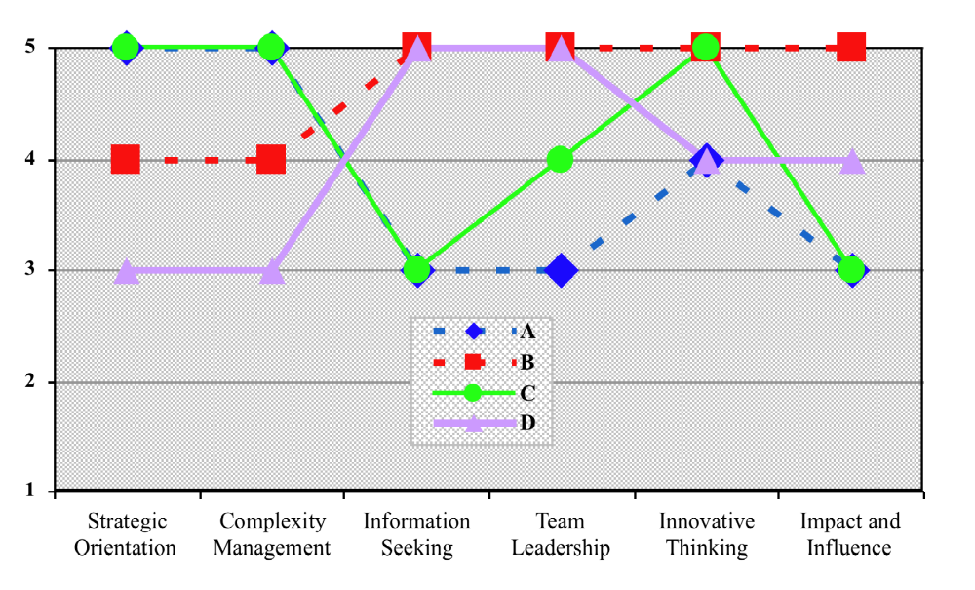

Exhibit 2

• Construct a Competency Array
Exhibit 2 (below) is a graph that can array the relative competency levels of potential board leaders. Click on the blank form shown in Exhibit 3 on the next page to complete the array for the position(s) and competencies being examined. Map on the blank chart each potential leader’s competency level, based on the combination of their incoming selection assessments, trustee peer assessments, and both educational and boardroom achievements. As an illustration, the hypothetical chart below shows six different competencies that one board might have chosen as its most important. The letters A, B, C, D represent specific individuals under consideration for leadership positions. A scale of 1 to 5 is used, with 1 being low and 5 being high, to plot their competency levels:
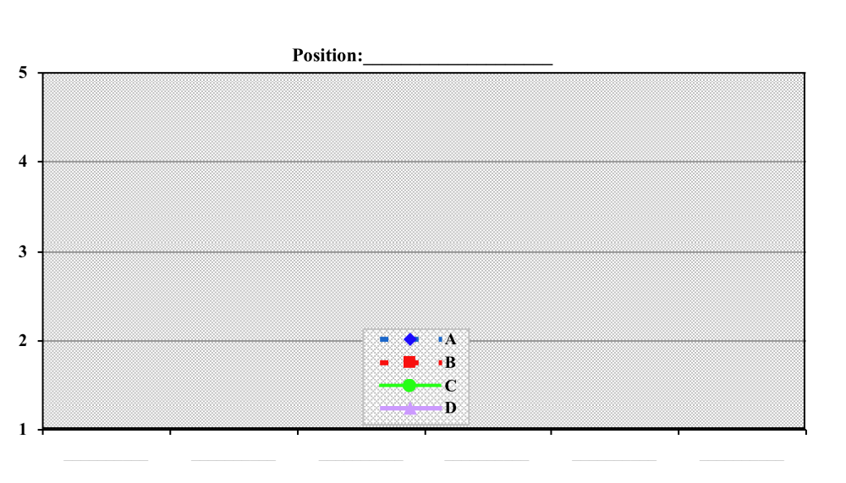Click on the blank form (above) to fill in the competencies that are most important for each body (committee or full board) that needs a new leader. Then graph each candidate’s competency levels against the five-point scale, as explained above. You can duplicate this form for each position you are examining.
Exhibit 3

• Identify Potential Trade-Offs Associated with Each Candidate
Once the candidates’ competency levels have been arrayed, it is likely that more than one will be worthy of consideration, so the selection of the leaders to be nominated will require making trade-offs. Certainly it would be ideal if every candidate for a board leadership position scored very high on all six leadership competencies. Yet the reality is that each of us has strengths and weaknesses. If your trustees are being honest with each other, these will emerge in the peer evaluations.

Data-based selection helps to frame these trade-offs based on information about how each trustee’s competencies were perceived by those who interviewed him or her during the initial board member selection process and by his/her peers during the trustee effectiveness assessment process. This means that the key question facing those who select board leaders is to identify where the strengths can be leveraged and where the weaknesses can be bolstered through complementary staffing, described below, and/or mentoring. The challenge will be to sort out the implications of the trade-offs that exist between each individual’s development and potential effectiveness in a leadership position.

Trade-offs. For example, if faced with the hypothetical trustee profile in Exhibit 2 on
page 77, you might argue that trustee B is particularly strong in several of the leadership competencies that will be critical to leading the Governance Committee if teamed with the board chair to ensure that he’s working in the right strategic context.

Complementary staffing. Complementary staffing means that if you see an individual as having leadership potential but he or she has not yet demonstrated a key leadership competency, you should ensure that the individual gets exposure to activities that will build that competency and consider staffing the rest of the committee to include one or two trustees who have particular strengths in that competency. This is also a situation in which feedback and guidance to the individual is likely to help generate the motivation to develop that new competency through education or observation of other governance activities.

Mentoring. Trustee D in Exhibit 2 might be new to the board and not have had the opportunity to develop or demonstrate his or her strategic orientation and skills in complexity management. In the event that circumstances require naming someone like trustee D to a leadership position, the board may want to ensure that the board chair works closely with that individual in framing the committee’s agenda of work. If time allows, the board might also want to develop these abilities by putting the individual in situations where he or she could learn more about the institution and its strategic challenges before being appointed as a committee chair.

Alternatively, trustee C (Exhibit 2) has some compelling strengths but tends not to seek out additional information, which probably tends
to reduce this person’s influence with peers.
He or she might benefit from mentoring regarding what kinds of information need to
be assembled, by whom, and how to present
the resulting recommendations or committee views in a convincing manner to the full board. Most important is giving this trustee feedback so that he or she will know to look to others for consultation in the area where competence is less strong.

• Conduct a Structured Conversation with Each Leadership Candidate
Once the chair, the Executive Committee, or the Governance Committee has considered the competencies required, it makes sense to conduct a conversation with the individual candidates to address the following topics:
– Do you aspire to a leadership role on this board? If so, what role do you think best leverages your strengths? Why?
– What distinctive capability would you bring to that role?
– What would you want to accomplish if you were named to that role? What might be your leadership agenda?
– What kinds of activities would you like to undertake in advance of taking on such a role that would increase your likelihood of success?
– What other individuals on this board do you see as bringing abilities that you’d like to see brought to a leadership position? Why?

5. Developing Leaders and Planning
for Succession
Once candidates have provided answers to the above questions, their answers can be used, along with the results of the competency array, to place the appropriate candidates into the board’s leadership development and succession system and to develop the final slate of nominees for full board approval.

Examples of leadership development activities can include attendance at formal education programs, chairing a board committee or serving on a board task force, taking on a broader role with the hospital’s external constituents, or participating in
a mentoring relationship with a current or past board leader.

Effective board leader succession planning takes more than a few months to implement. Planning to fill board leadership positions two years in advance provides time for candidates to develop their skills and, in the case of board officers, to hold a chair-elect position, which allows an incoming chair to work closely with the current chair for a year before he or she assumes the
chair role.

Thank you for using the Competency-Based Governance Tool Kit. Your answers to the following questions will help the Center for Healthcare Governance further refine and improve the tools and resources included in the Tool Kit. Please complete a separate form for each set of tools that you used/reviewed.
Competency-Based Governance Tool Kit Feedback Form

1. Please circle the set of tools listed below about which you are providing feedback on this form:
• Board Member Peer Assessment tools: (Competency-Based Peer Assessment Process, GAP Peer Assessment Surveys, How to Use Peer Assessment Results, Personal Development Plan)
• Board Member Recruitment and Selection tools: (Interview Guide, Candidate Competencies Summary, Board Member Position Specification and Board Member Recruitment Process Guideline)
• Board Education resources: (Board Orientation/Education Model, Mentoring Guideline)
• Board Leadership Development and Succession Planning Tool
2. How easy to use/adapt were the tools you used with your board?
Not Useful Somewhat Useful Very Useful
1 2 3 4 5

What would have made the tools easier to use?

If no, what improvements could be made?

3. How did you use or do you plan to use the results you gained from implementing the tools?

4. How could the tools be improved for more impact?

Thank you for providing your feedback on the Competency-Based Governance Tool Kit. Please return your completed feedback form to the Center for Healthcare Governance to the attention of Mary Totten by fax at 312/422-4650 or by email to info@americangovernance.com.
Optional: If you are willing to have us call or email you to follow up on your comments, please indicate your name, affiliation, and contact information below:

Name: _________________________________
Position: _______________________________
Organization: ___________________________
Contact me at: __________________________

